# include<iostream>

using namespace std;

int add(int a,int b);

int main()

{

int x,y,sum;

cout<<"Enter two numbers:"<<endl;

cin>>x>>y;

sum = add(x,y);

cout<<x<<"+"<<y<<"="<<sum<<endl;

return 0;

}

int add(int a,int b)

{

return a+b;

}

# include<iostream>

using namespace std;

int add(int a,int b);

int main()

{

int x,y,sum;

cout<<"Enter two numbers:"<<endl;

cin>>x>>y;

sum = add(x,y);

cout<<x<<"+"<<y<<"="<<sum<<endl;

return 0;

}

int add(int a,int b)

{

return a+b;

}

程序代码

结果

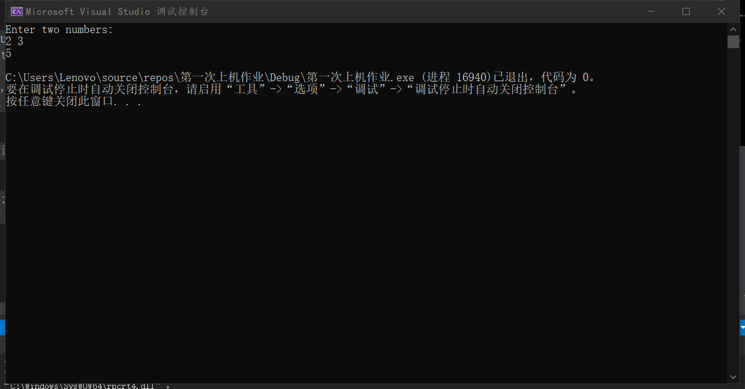

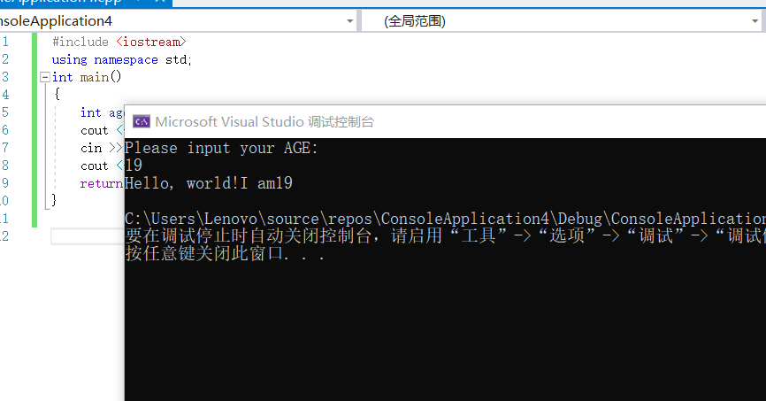

感悟：通过这次实验，我了解到了c++程序的简单使用和如何进行程序的编写。

Copyright ©2021-2099 luanxiang wang.All rights reserved